EENG 3920: Modern Communication Systems Design

# **Lab 6 - Experiment 14: Sideband Modulation and Detection**

Group 5

Victor Rodriguez (victorcuba92@gmail.com)

Mohammad Qawash (MohammadQawash@my.unt.edu)

John Rolfe (JohnRolfe@my.unt.edu)

Natalie Powers (NataliePowers@my.unt.edu)

Nathan Ruprecht (nathan.ruprecht@outlook.com)

**Date of Submission: 21 April 2016**

**Section 1**

**Introduction and Learning Objective**

EENG 3920 is the project design course for electronics courses. Students are required to design electronic communication systems with electronic devices such as MOS transistors, capacitors and resistors. The design and simulation tool is NI ELVIS platform. Topics include LC circuits and oscillators, AM modulation, SSB communications, and FM modulation. At the end of the class, the student should be able to: Understand fundamental concepts and circuits used in communication systems; Describe principles and theory of various communication techniques such as AM, FM, and SSB; Conduct effective analysis and interpretation of the experiments; Demonstrate the ability to identify, analyze, and solve technical problems; Creatively apply the course topics to designs; Simulate and analyze advance electronics circuits with NI ELVIS instruments and other test equipment.

For this experiment we investigated the behavior of a negative clamper, studied class C bias and amplification, and understood the theory of frequency multiplication.

**Safety guidelines**

As mentioned in the lab procedures, safety is extremely important in the lab. In the event of electrical fire, the session 1 lecture note states to use the fire extinguisher, located at the front of the lab, then to vacate the lab, close the door and ring the fire alarm.

**Section 2 / 3**

**Theoretical Background**

A balanced modulator is typically used to generate a double-sideband suppressed carrier signal in an SSB transmitter that uses the filter method of design. Nonlinear amplification causes the creation of first and second harmonics of the intelligence input signal, the simple sum and difference frequency components, and a dc component. The first and second harmonics of the carrier input signal, which are normally produced in mixing action are suppressed in a balanced modulator. In the 1496, this is done by signal cancellation due to the symmetrical arrangement of the differential amplifier stage. A spectrum diagram of the output signal reveals the presence of the lower and upper sidebands but no RF carrier frequency component. To produce single sideband, a sharp filter that exhibits a fairly constant passband response and steep roll-off skirts is needed to attenuate all frequencies produced by a balanced modulator except for the desired sideband. A ceramic filter such as the one used in Experiments 2 and 9 may fit these design requirements.

**Exercises**

Procedure:

At first, we built the first circuit shown in the textbook, applied a positive and negative 10V to the circuit with a 2V peak-peak, 400kHz sine wave at test point 1. This signal represents the input RF carrier. We adjusted the potentiometer to get a minimum amplitude sine wave at test point 3, Vout. Output is below.

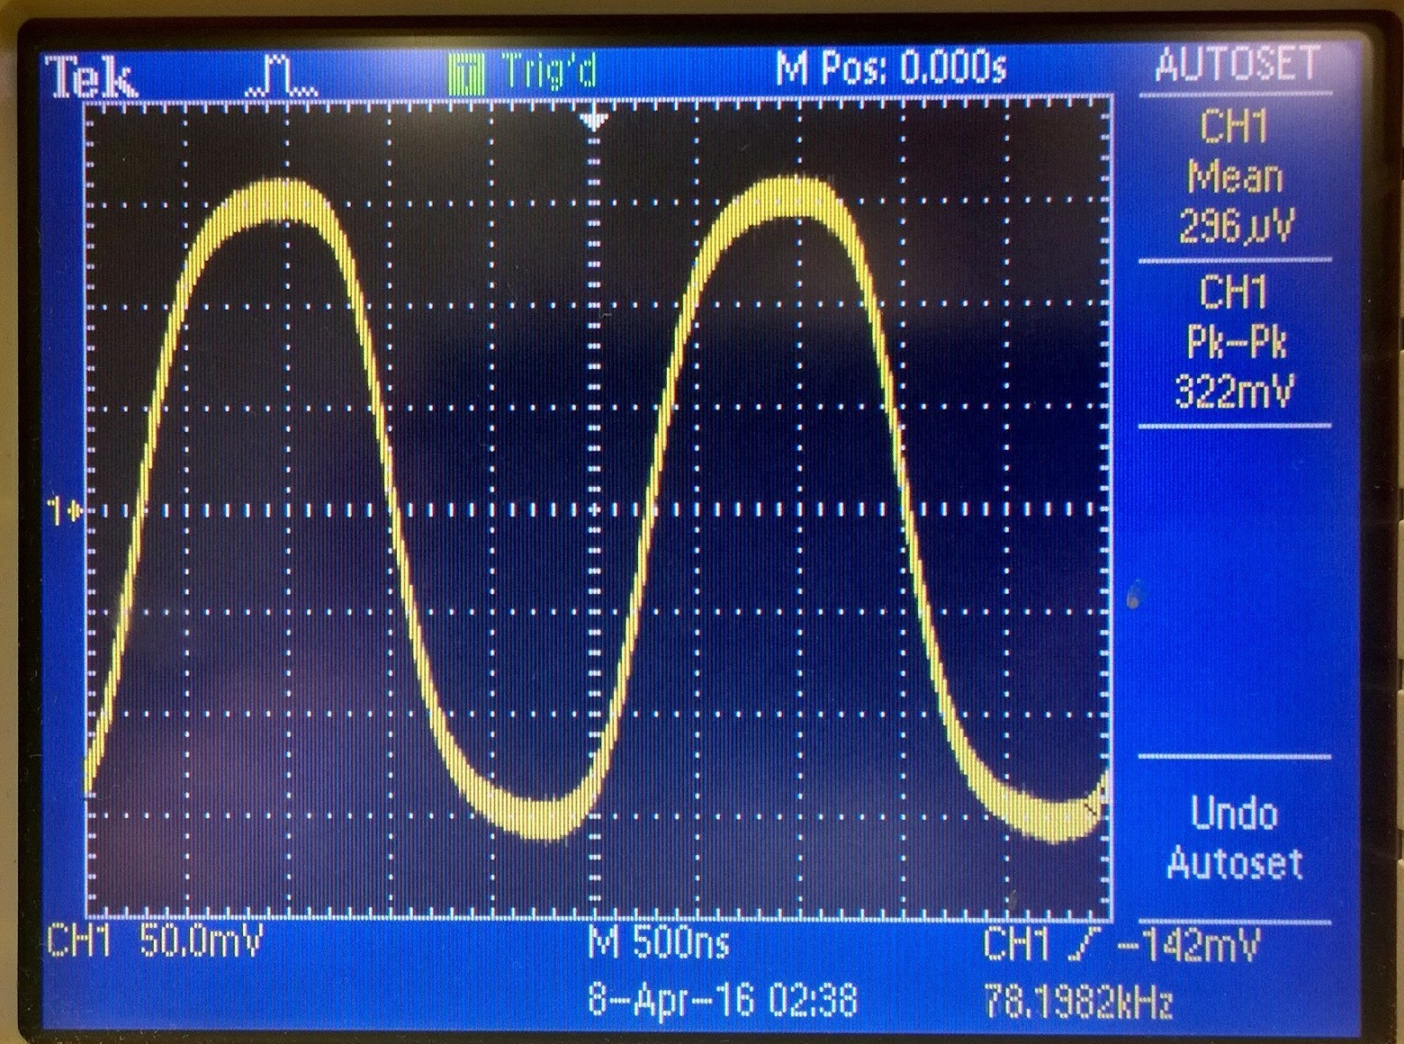

Step 1 output

In step 2, we applied a 150 mV peak-peak, 200 Hz sine wave at test point 2, This signal represented the input audio intelligence signal. We again monitored test point 3 and were expecting to see a “fuzzy” 400 kHz sine wave. The output is below.

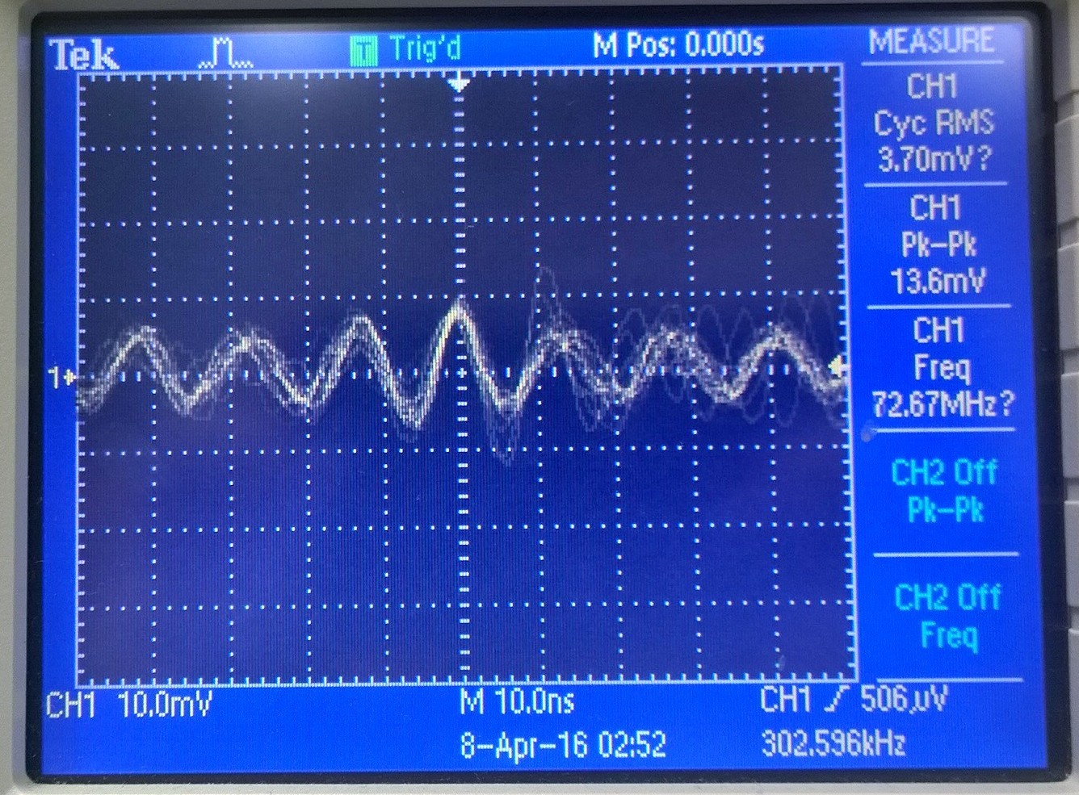

Step 2 output

After adjusting the time scale and making the potentiometer a different value, we got much better looking sine waves at testing points 2 and 3, shown below.

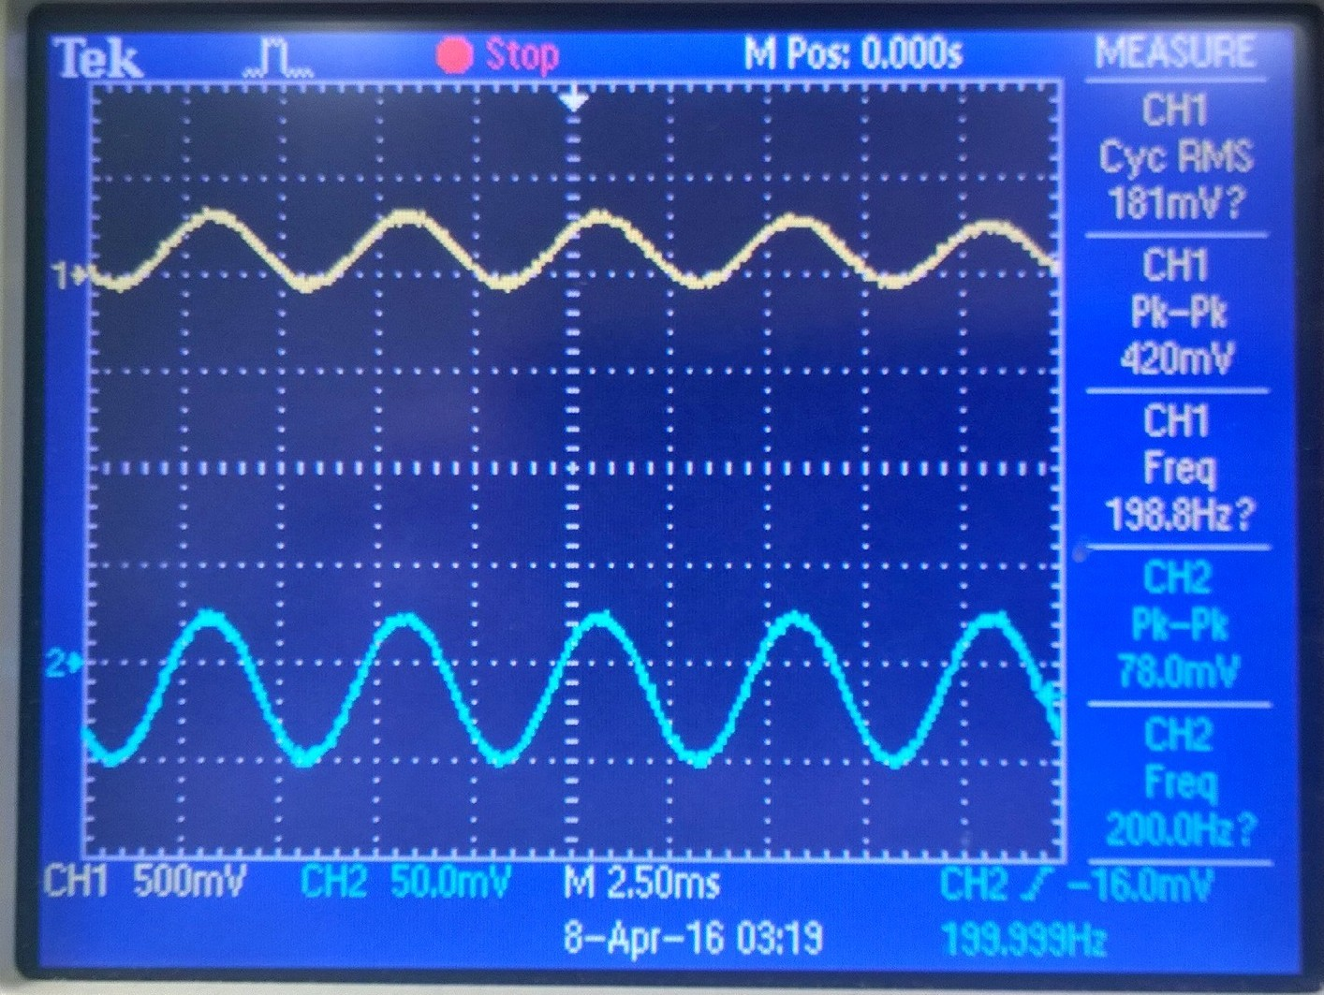

Step 3 output

Step 4: Changing the intelligence frequency results in changing the output by what seems to be a 1 to 1 ratio. Changing the carrier frequency results in the output looking like 14.6 where it looks like a solid sine wave on each side of the x-axis.

The next step was us applying the DSB-SC signal to the vertical input of the scope and applying the intelligence signal to the horizontal input of the scope. The result is that “bow-tie” look on the oscilloscope as shown below.

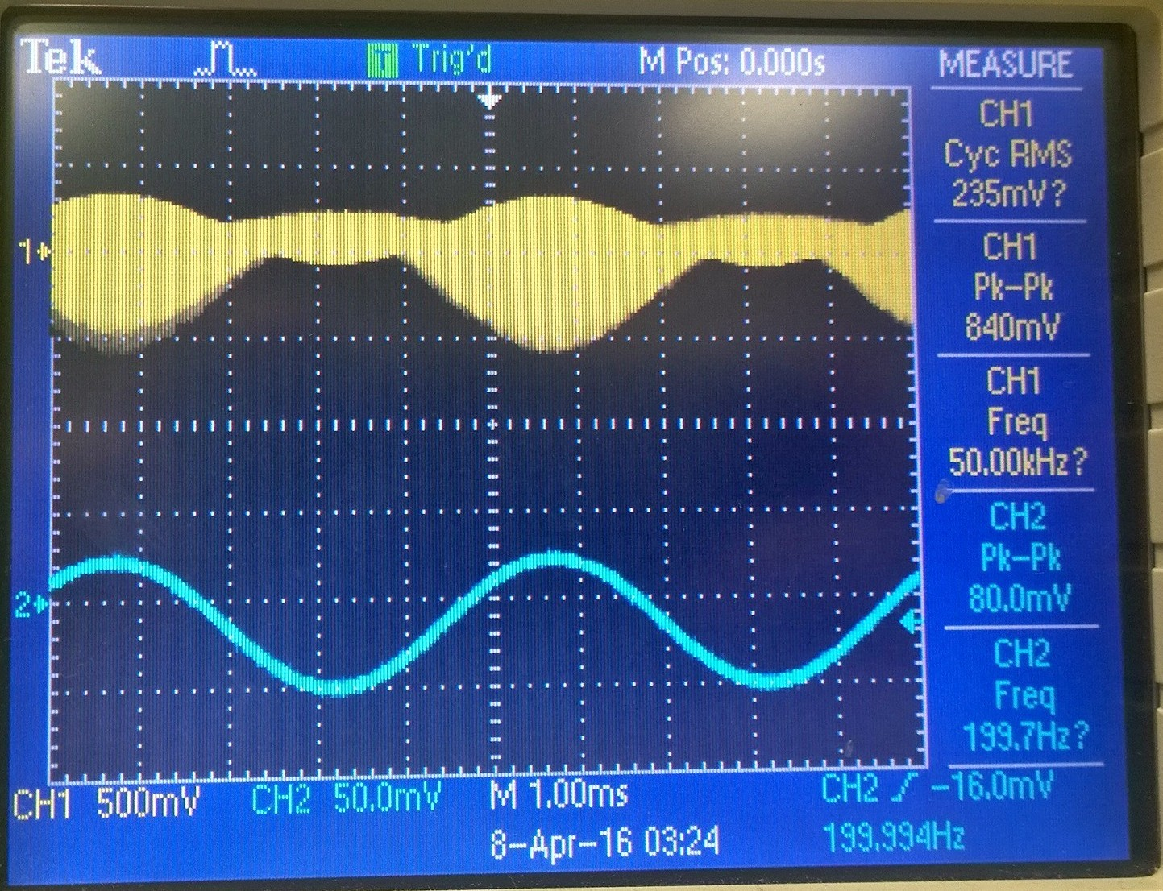

Step 5 output

Now we send the signal through the ceramic filter to produce a true SSB look. We adjusted the carrier frequency so that the voltage at test point 5 is at maximum amplitude.

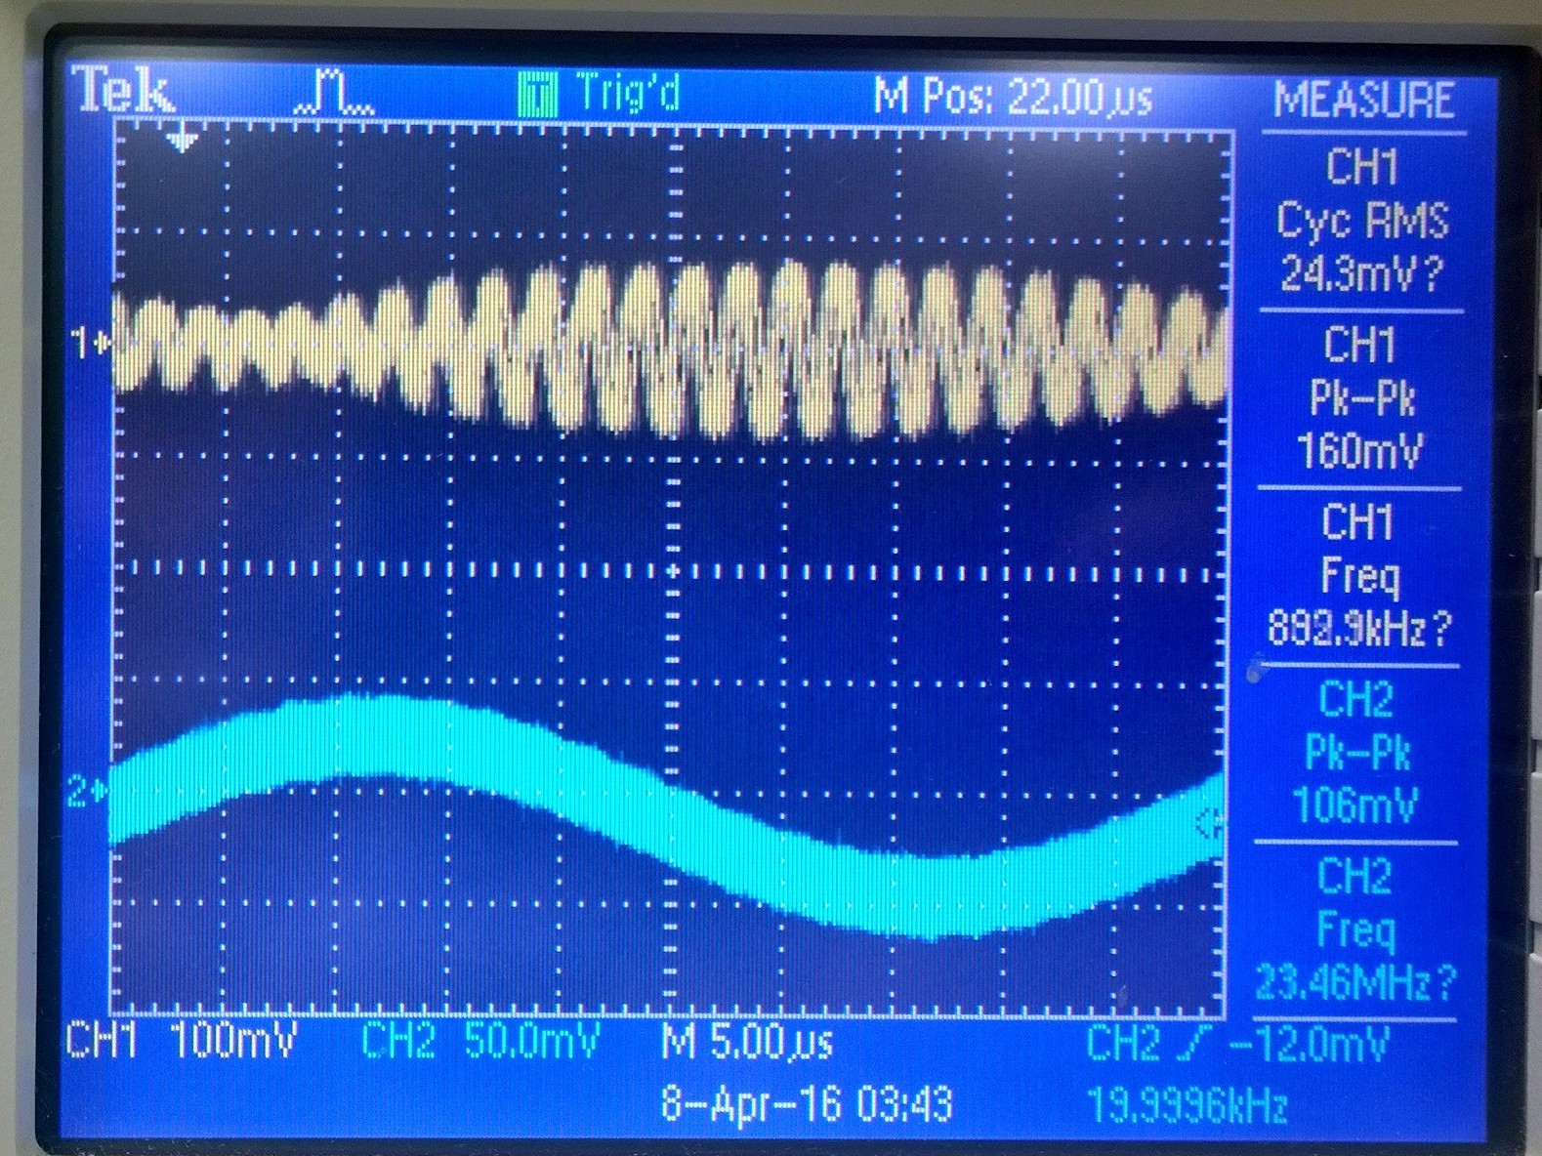

Step 6 output

fUSB = 455kHz fcarrier = 435 kHz

We repeated step 6 but this time only allowing the lower sideband frequency component of the DSB-SC signal to make it through the ceramic filter.

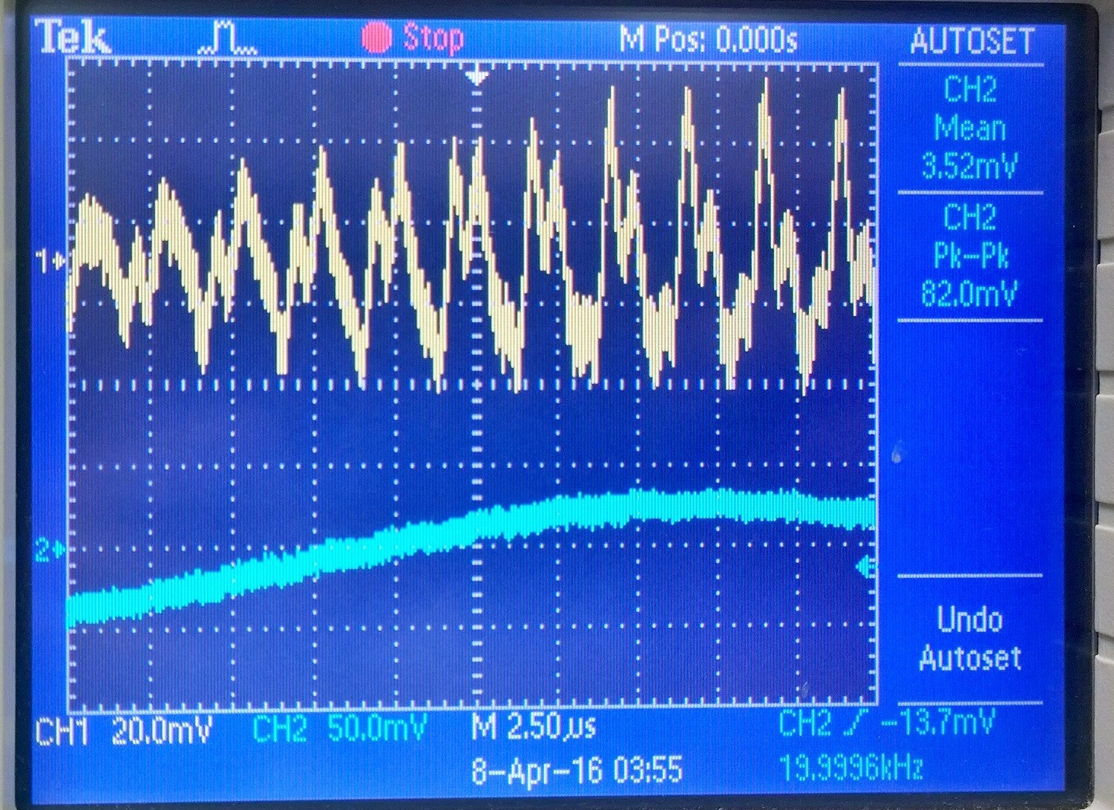

Step 7 output

fLSB = 415 kHz fcarrier = 435 kHz

Step 8 was building the next half of the circuit and sending the outputted signal before as the input signal to this circuit. After changing the amplitude of Vc to 3.5V peak-peak, we took a picture of the oscilloscope and pasted it below.

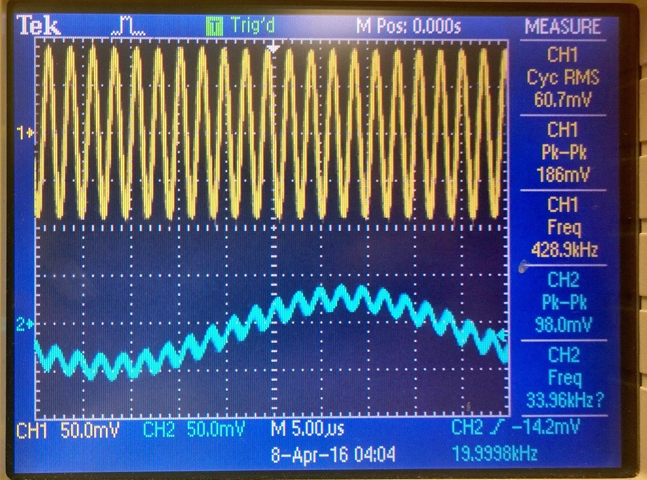

Step 8 output

We adjusted the intelligence frequency to 200 Hz and found the largest peak in the result. Oscilloscope screenshot is below.

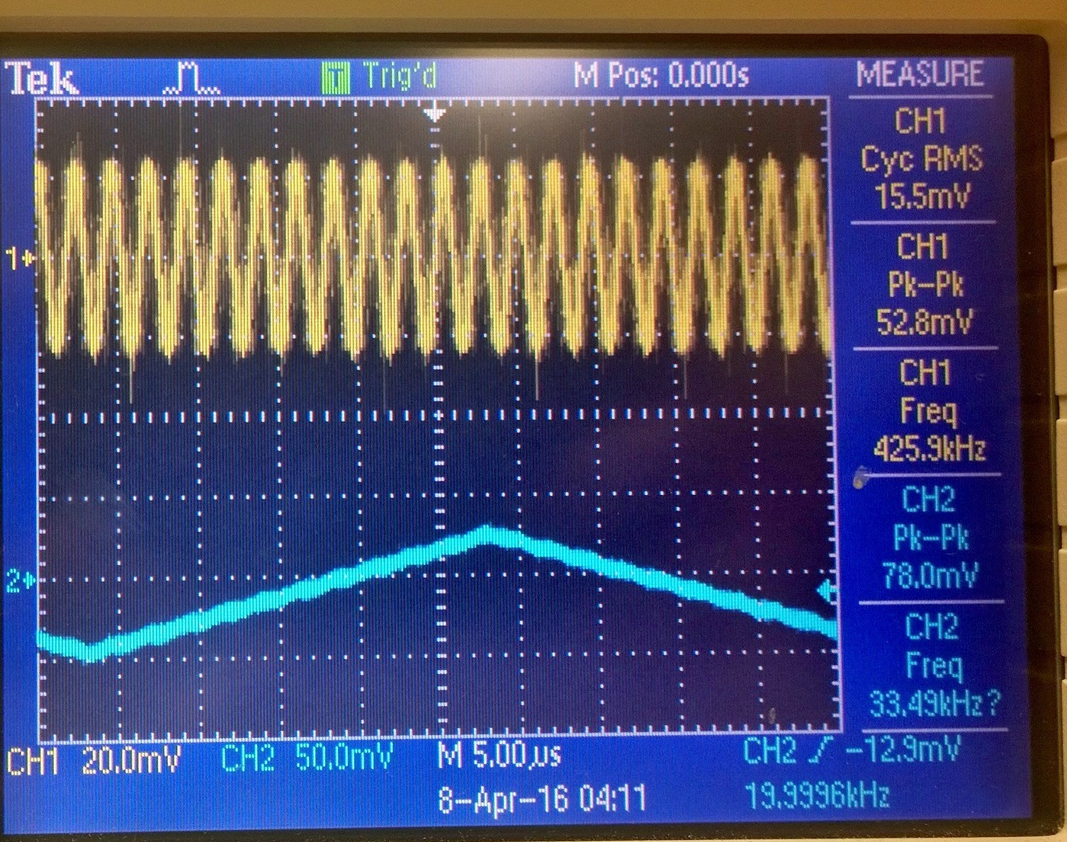

Step 9 output

No real change. Peak ~440 kHz

We adjusted the intelligence frequency to 20 kHz and found the largest peak in the result. Screenshot of the oscilloscope is below.

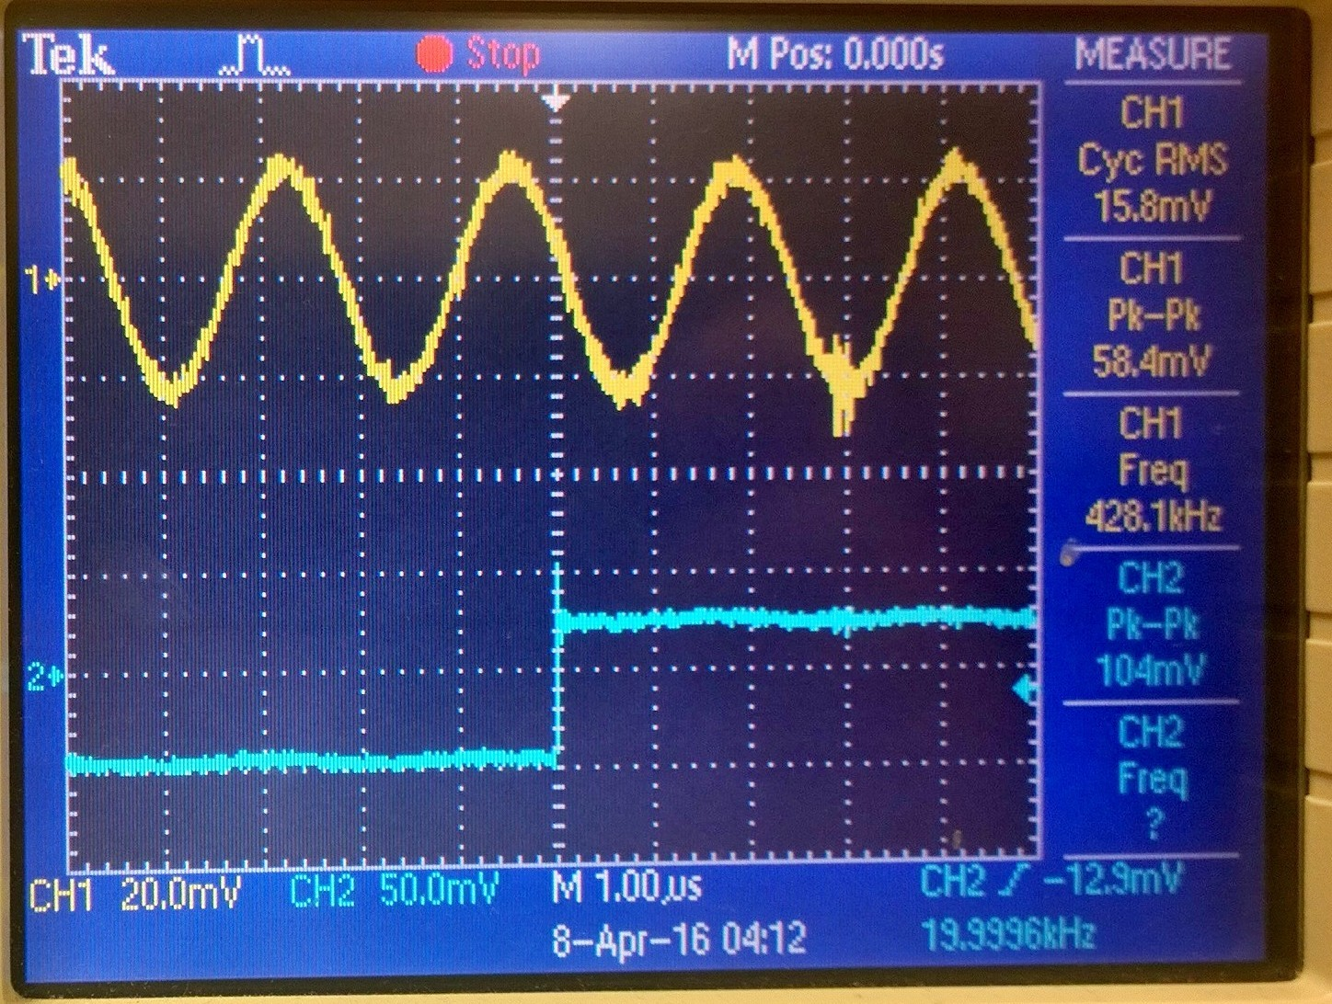

Step 10 output

No real change. Peak ~440 kHz

Step 11 was making the function generator to produce a 20 kHz triangle wave instead of a sine wave. Output is below.

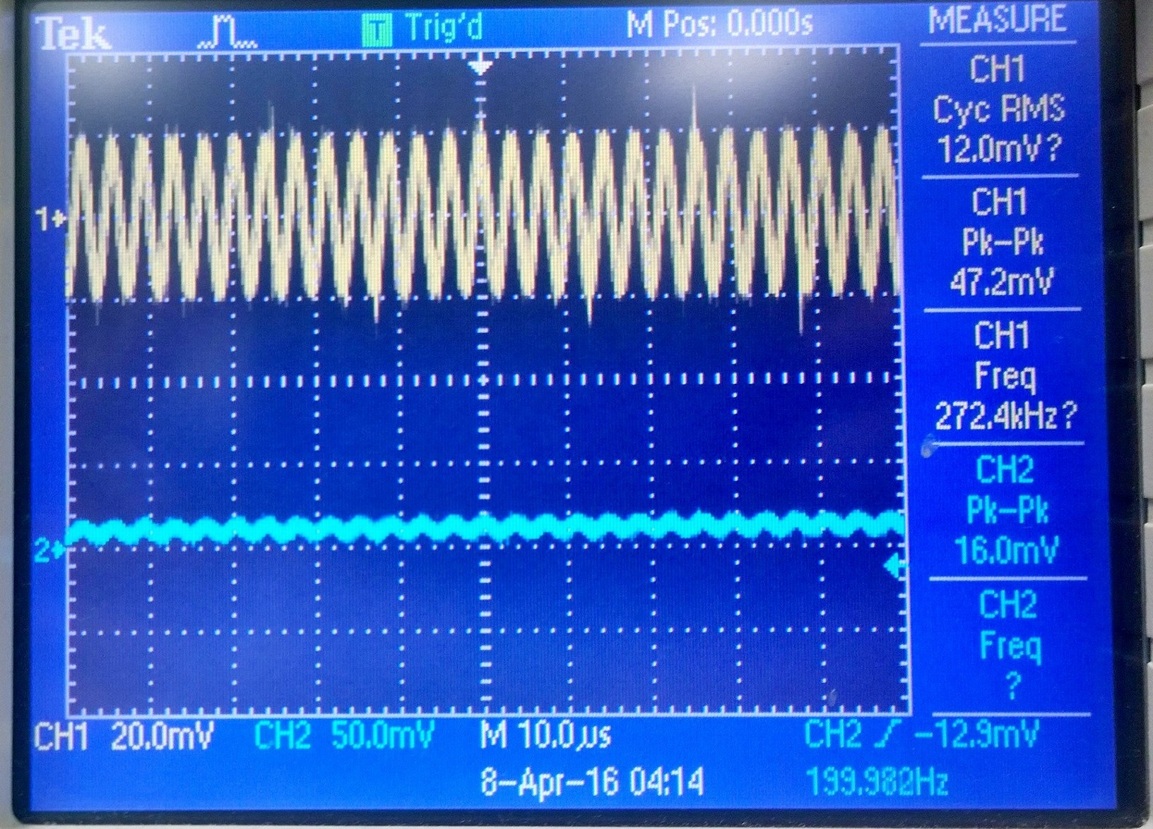

Step 11 output

When we made the intelligence signal to produce a 200 Hz triangle wave and tuned the RF carrier so that just the upper sideband or lower sideband frequency component is passed by the ceramic filter, the product detector should recreate the original triangle wave with minimal distortion. This didn’t happen at all for steps 12-14. The output showed no real pattern, nor could we adjust the carrier frequencies to make a difference.

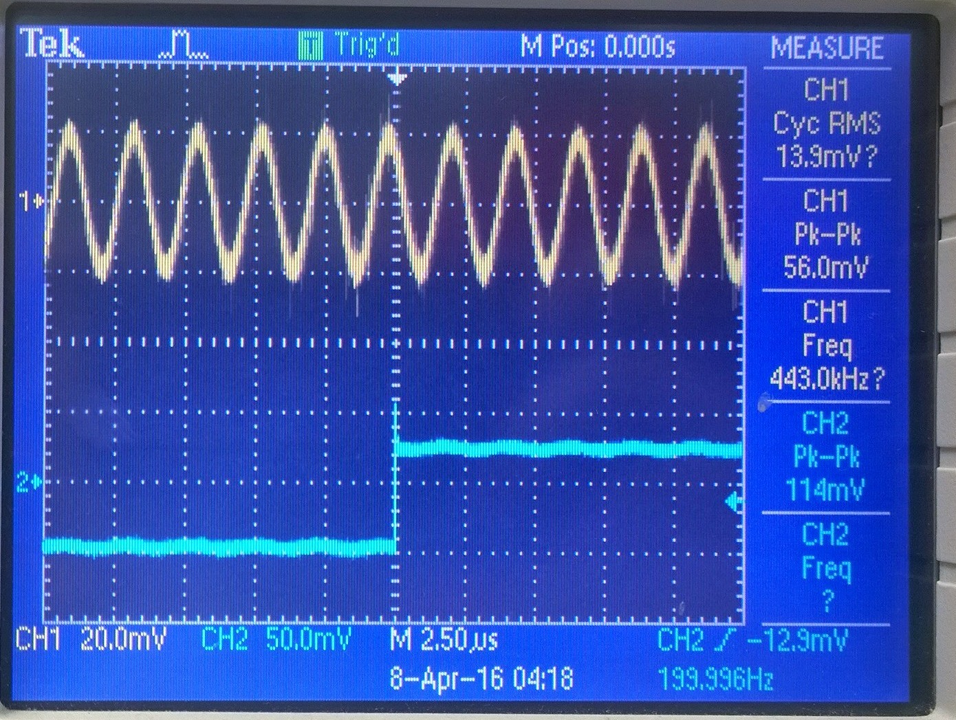

Failed step 12-14 output

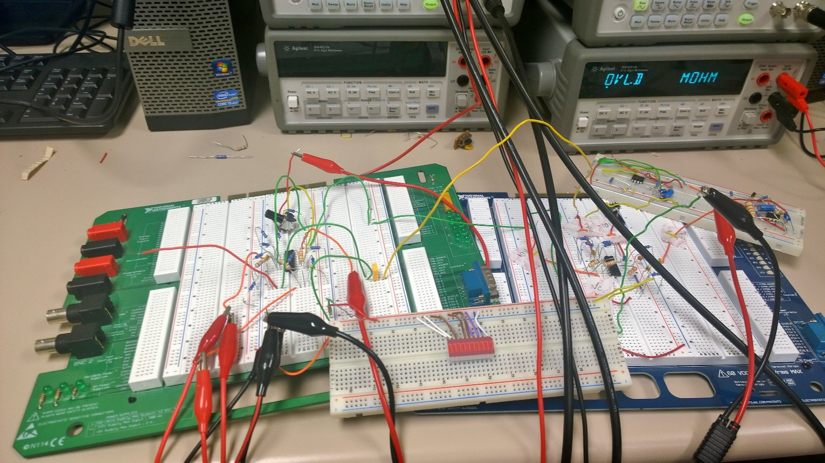

Our circuitry for this lab. We used a breadboard for each half of the lab.

**Section 4**

**Conclusion**

In the end, we were able to complete almost all of the procedure for success except the last bit. We could not get the output to match the input even though we had the carrier and intelligence signal frequencies matched to specs. We were able to somewhat successfully able to output a frequency modulation as shown in the responses displayed above.

# **References**

Agilent Technologies, 2007, *Agilent 34401A 6 ½ Digit Multimeter, User’s Guide*.